Chapter 9: Understanding Randomness

1. **Generating Random Numbers using Data Analysis:**
2. Open a new excel sheet.
3. Select the **Data** tab $⟹$**Data Analysis**.

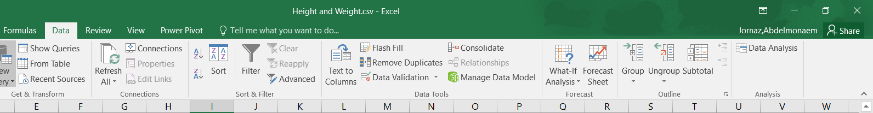

1. The **Data Analysis** box will appear, select **Random Number Generation** and click **OK.**

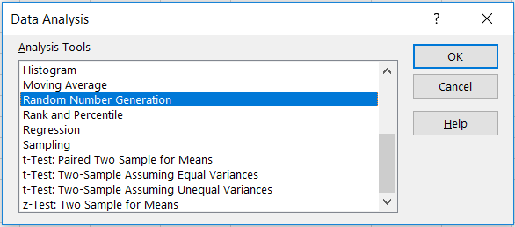

1. **Random Number Generating** box will appear. Select **Number of Variable** and **Number of Random Numbers** that we want to generate (sample size), then select the **Distribution**, lower and upper number, and the output rang, then click **OK**.

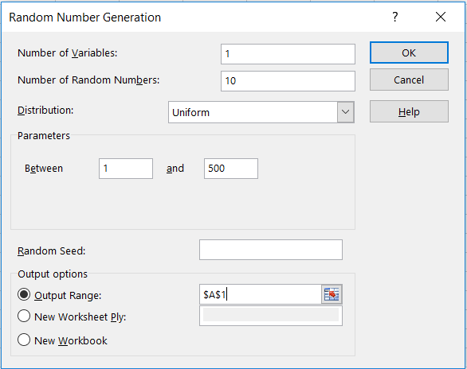

1. The result is

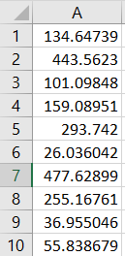

1. To convert the real values to integer values, select all the values and click on the right mouse button, then following box will appear, select **Format Cells…**.

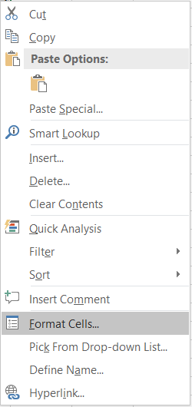

1. In the **Format Cells…**, select Number, then select **Decimal Places** and set it equal to 0, then click **OK**.

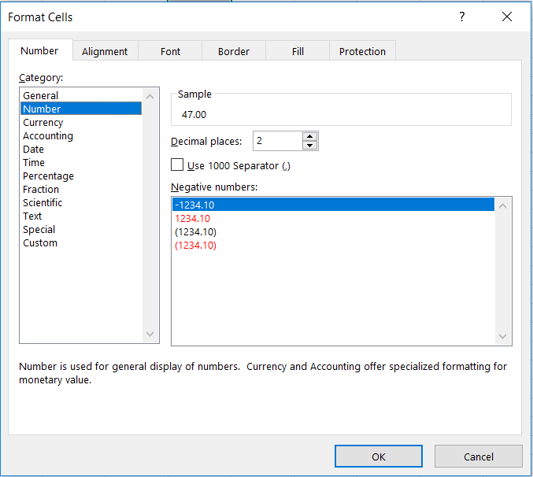

1. **Generating Random Numbers using Formula:**
2. Select the **Formulas** tab $⟹$**Math & Trig $⟹$ RAND**.

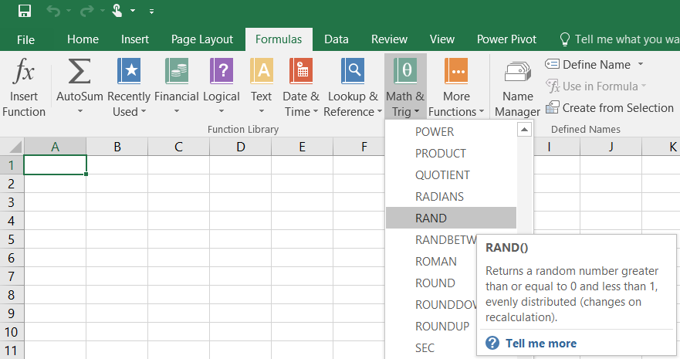

1. The function **RAND** returns a real number between 0 and 1.

**Note:** RAND calculates a new value every time the worksheet is calculate. To lock random numbers from being updated, copy the cell that contain RAND, then use paste values.



1. The results is



1. To generate more than one value, we can copy the formula and paste it in the other cells or we can select the cell and click on the tiny square in the bottom right of the selected cell and dragging it to the cell where we want copy the formula.

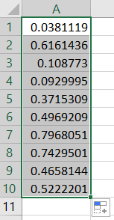

1. **RAND** returns a number between 0 and 1. If we want to generate an integer number, we can use the function **RANDBETWEEN**.



where bottom and top are integers representing the lower and upper value of the range.



1. The result

